**Self Check**

**根据短文内容，从方框中选择恰当的单词填空，注意形式变化。**

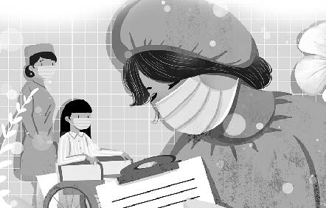

|  |
| --- |
| Internet, result, magazine, however, although, together, almost, online, hardly, make |

Do you know about a woman called Zheng Xuan? She is China's first deaf doctor of linguistics (听障者语言学博士). She is good at Chinese Sign Language (中国手语) and American Sign Language. Now she is teaching at a university (大学) in Chongqing.

Zheng Xuan became deaf as a(n) (1)_______ of a medical accident (医疗事故) when she was only two years old. To make her speak, her grandmother stopped working and came to live (2)_______ with her. She spent (3)_______ all her time teaching the little girl to speak. After four years of hard work, Zheng Xuan started to speak.

When Zheng Xuan was young, she enjoyed reading picture books and (4)_______ like other children. At the age of six, she started school. She was very smart. (5)_______ she was deaf, she still did very well in all her lessons. In 1998, she started to study at Wuhan University. She met some other deaf people and (6)_______ friends with them. The next year, she learned to use the (7)_______. From then on, she often went (8)_______ and talked with her deaf friends.

In 2009, Zheng Xuan became a university teacher in Chongqing and started to teach her students sign language. She is often very busy with her work and (9)_______ has any time to relax. (10)_______, she always spares (匀出) some of her time for deaf people and helps them.

**答案**

**Self Check**

1. result  2. together  3. almost  4. magazines 5. Although

6. made  7. Internet  8. online  9. hardly  10. However